Features of heavy metals mobility in the sampling points with their high concentration on the area of tailings dam of Dzhida tungsten-molybdenum mining-concentration complex in the Buryatia republic, Russia
Angelina Sarapulova^{1, 2}, Olga Smirnova¹, Bayarma V. Dampilova¹, Irina Bardamova¹, Svetlana G. Doroshkevich¹

¹ Geological Institute, SB RAS, Sahyanovoy St. 6a, 670047 Ulan-Ude, Russia, meta@gin.bscnet.ru
² Karlsruhe Institute of Technology, Hermann-von-Helmholtz-Platz 1, D-76344 Eggenstein-Leopoldshafen, Germany, angelina.sarapulova@kit.edu

In a modern society with highly developed industries and mining operations, serious questions often arise concerning heavy metal soil pollution which may occur as a result of the enrichment of natural raw materials. The main reason is Acid Mine Drainage (AMD) which formed from chemical reaction between water and rocks containing sulfur-bearing minerals (pyrite). The acid runoff further dissolves metals such as copper, lead and zinc into ground or surface water. The problems associated with AMD are the contaminated drinking water, disrupted growth and reproduction of aquatic plants and animals.
Within the oxidation zone of tailings dam of Dzhida tungsten-molybdenum mining-concentration complex various migration schemes are observed depending on the different chemical properties of elements. To assess possible landscape pollution and to protect natural ecosystems, information about total contents of heavy metals in soils, water, and air is less important than understanding the ionic species which are present, the mobility of these species and the percentages of them that are accessible to vegetation, and the conditions under which these mobile forms are most likely to migrate within soils in particular.
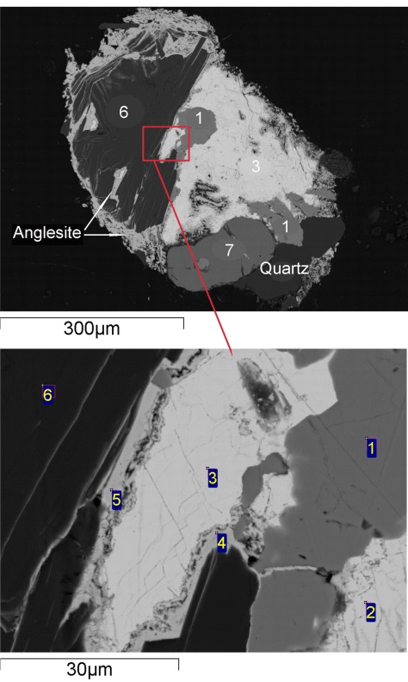
In this case, sequential extraction procedures have been widely applied. As a result of comparison of two technique of Pb, Cu and Zn selective extraction (BCR procedure and Tessier’s fractionation scheme), our experimental data show that both methods have good recovery and similarly describe the distribution of heavy metals on geochemical fractions. However, Pb mobile forms correspond to the first fraction of the BCR procedure are lower then the sum of the first and second fractions (mobile forms) of the Tessier procedure. The BCR procedure [1] in comparison with Tessier’s procedure [2] provides stabilization of some processes such as lead fraction dissolution followed by adsorption of Pb on slightly soluble products of the sulfide ores oxidation or precipitation as more stabile minerals. On the Fig. scanning electron microscopy investigation shows that cerussite and anglesite forms a cover, protecting sulfide from the further oxidation.

Using sequential extraction procedures the different characters of heavy metals mobility in the soils Zn>Cu >Pb and technogenic sands Pb> Zn> Cu were established. During our investigation we revealed regularity that heavy metals mobility sequence in soils and technogenic sands depends on ratio between heavy metals and organic matter concentrations.

Fig. SEM images of polished sample of technogenic sand. 1 – sphalerite, 2, 3 - galenite, 4, 5 - anglesite, 6 – biotite, 7 – pyrite

This work was supported by the complex integration project of the Siberian Branch of the Russian Academy of Science № 112 “Geochemical and biological factors of chemical elements migration in geosystems” and Russian Foundation for Basic Research, initiative projects 08-05-98042-r_sibir_а and 13-05-01155.

References
[1] Junhui Li, Ying Lu, Hojae Shim, Xianglian Deng, Jin Lian, Zhenglei Jia and Jianhua Li. J. Environ. Monit. 12, 2010, 466–471
[2] Tessier, A., Campbell, P. G. C., Bisson, M.. Analytical Chemistry. 51, 1979, 844–851

