Occurrence of Perfluoroalkyl Surfactants in the river Saale, Halle

Umer Shafique^{1,2}, Stefanie Schulze¹, Christian Slawik¹, Albrecht Paschke¹, Gerrit Schüürmann^{1,2}
¹ UFZ Department of Ecological Chemistry, Helmholtz Centre for Environmental Research, Permoserstraße 15, 04318 Leipzig, Germany
² Institute for Organic Chemistry, Technical University Bergakademie Freiberg, Leipziger Straße 29, 09596 Freiberg, Germany
For Correspondence: Umer Shafique, Email: muhammad-umer.shafique@ufz.de, Tel: +49 341 2351087

Perfluorocarboxylic acids (PFCA) and perfluorosulfonic acids (PFSA) have received public attention because of their uncongenial characteristics such as persistence, bioaccumulation potential, and possible adverse effects on biota (Ahrens & Bundschuh 2014). Perfluorooctance sulfonate (PFOS) and perfluorooctanoic acid (PFOA) were the two most frequently detected substances, and PFOS has already been added in 2009 to Annex B of the Stockholm convention on persistent organic pollutants. PFOA was planned to be reduced by 95% until 2010 and to be eliminated completely from emissions and products until 2015 but is still being found in environmental compartments (Li et al 2015; Zhao et al 2015). Moreover, several other PFCA and PFSA homologues are still ubiquitously present with yet unknown hazard potentials.

The present communication focuses on the occurrence of 16 perfluoroalkyl surfactants (11 PFCAs and 5 PFSAs) in the river Saale in the Halle area. Surface water samples were collected actively (grab samples over the period of 20 days after every 4 days) and passively (with sampling devices POCIS and Chemcatcher® exposed for 10 and 20 days) from three different locations in February 2015. Water flow velocity was monitored using passive flow monitors (PFM). Samples were extracted using Chromabond® anion exchanger and analysed using LC MS MS in accordance with DIN standard method. ΣPFCA concentrations ranged from 80.7 to 141.4 ng L^{–1}. PFOS has not been detected at any location in the present study, and perfluorobutane sulfonate (PFBS) is the only PFSA detected. It is reported that Germany has stopped the production of PFOS 8 years ago, with PFBS most often serving as replacement. Interestingly, we found high PFBS concentrations in the outflow of a treatment plant, indicating that the latter is not only unable to remove this compound from the water body, but may even act as a point source of contamination. Our results suggest to investigate in more detail the impact of wastewater treatment plants on the occurrence of these pollutants in surface waters. The discussion includes recent profiles of these 16 PFCA and PFSA compounds in the waters of the left-bank tributary of the river Elbe, and a comparison with respective concentration levels in surface waters of Germany over the last 10 years.

Financial support through a scholarship from HEC Pakistan and DAAD Germany for Umer Shafique is gratefully acknowledged.
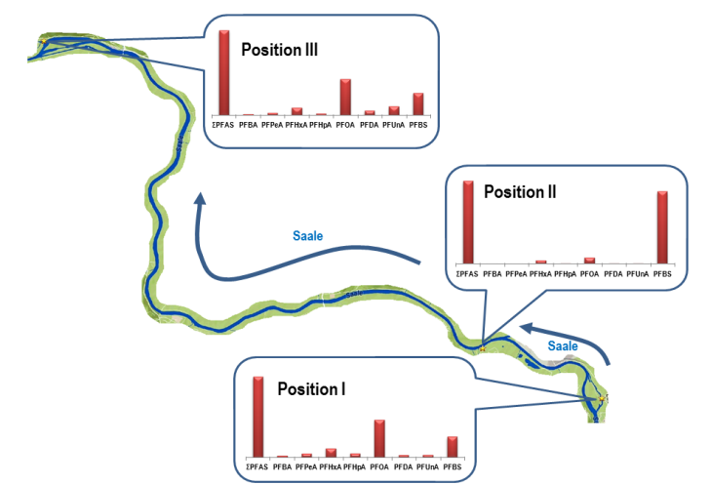

References

Ahrens L, Bundschuh M 2014. Environ. Toxicol. Chem. 33: 1921-1929.

Li L, Zihan Z, Jianguo L, Jianxin H 2015. Chemosphere 129: 100-109.

Zhao Z, Xie Z, Tang J, Sturma R, Chen Y, Zhang G, Ebinghaus R 2015. Chemosphere 129: 118-125.

