Study on the ozonization with special focus on the environmental and economic issues in the 4th stage waste water treatment
József Németh, Viktor Sebestyén, Utasi Anett, Dr. Juzsakova Tatjána, Dr. Endre Domokos, Dr. Árpád Kárpáti, Prof. Dr. Ákos Rédey

¹ Institute of Environmental Engineering, University of Pannonia, 10 Egyetem St., Veszprém, 8200 Hungary, jnemeth@almos.uni-pannon.hu

Due to the drastic growth in population and in industrial and economic outputs the demand for waste water treatment is continuously increasing. The high ammonium content, the amounts of detergents, the presence of biologically hardly decomposing compounds, the phosphorous and salt contents in the waste water necessitated the continuous developments in the waste water treatment technologies. The residues of pesticides and pharmaceuticals and their decomposition products, the persistant materials in the waste water requested additional new developments in the technologies. According to the Water Framework Directive of the European Union surface waters of good quality are targeted and should be reached.
The protection of the water reservoirs is a distinquished objective, therefore direct waste water discharges are not allowed and not tolerated at all. Therefore higher and higher waste water treatment efficiencies should be achieved in the waste water treatment.
There are several technological alternatives how to cope with this problem. The ozonization, the sorption processes, the membrane technologies, the photochemical oxidation, the oxidation with chemicals or the combined processes to remove the biologically non-decomposable materials can be mentioned. These steps are usually the finishing processes in the waste water treatment. These technologies are the so called 4th stage waste water treatment technologies.
The ozonization is a well and easily adaptable technology by which the persistent, biologically non-decomposable materials can be removed with high efficiency.
The objective of the paper is to study the effect of the ozonization in waste water treatment from environmental and economic points of view.
The efficiency of the ozonization highly depends on the residence time of the ozone in the reactor and on the operational parameters.
During the laboratory experiments (Fig.1.) the residence time was set to 5,10,15,20,25,30 and 35 min.
The waste water introduced into the ozonizator was the effluent of a communal waste water treatment facility.The efficiency of the ozonization was followed with COD and BOD measurements. Model persistent organic material was introduced into the inlet waste water stream in order to simulate the real technological conditions. The treatment efficiency was followed in the function of the operational parameters.
On the basis of the laboratory experiments it can be concluded that the ozonization can be expediently used to remove the detrimental persistent components from the waste water with good efficiency, however, the operational cost increases.
Following the laboratory experiments pilot plant experiments are planned to be implemented to obtain a comprehensive picture on the process from environmental and economic points of view.
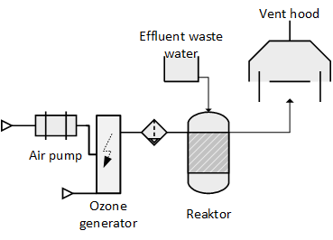
Fig 1. Laboratory experimental system
Keywords : 4th stage waste water treatment, oxidation procedure, ozonization

