Molecular dynamics modeling of herbicide adsorption by goethite:
4-chloro-2-methylphenoxyacetic acid (MCPA)

Michael Kersten¹, Daniel Tunega², Ivelina Georgieva³
¹ Johannes Gutenberg-University, J.-J. Becherweg 21, D-55099 Mainz, Germany, kersten@uni-mainz.de
² BOKU Institute of Soil Sciences, Peter-Jordan-Str. 82, A-1190 Wien, Austria, daniel.tunega@boku.ac.at
³ Bulgarian Academy of Sciences (IGIC), Sofia, Bulgaria, igeorgieva@svr.igic.bas.bg

Interactions between the soil hydroxide mineral goethite (α-FeOOH) and the ionic organic herbicide agent MCPA were studied using density functional theory (DFT) and molecular dynamics (MD) calculations. Different surface OH groups and MCPA proton states were used to mimic the effect of pH on the theoretically possible outer- and inner-sphere surface complexes, their binding energies, and bond lengths. Modeling not only a solvated but also protonated mineral surface provided a major breakthrough showing that there were energetically optimized hydrogen bonded MCPA structures on the predominant (110) goethite crystal plane. Both an outer-sphere complex with the MCPA anion, and a monodentate inner-sphere complex with the neutral MCPA molecule, were found as the most energetically stable. The latter is predominating at pH < pK_{a} = 3.1, i.e. the acidic pH range. This means that MCPA is very weakly sorbed at typical soil pH values. The MD modeling results predicted the innersphere complex forming by sharing one of the oxygens between the MCPA carboxylate group and a singly coordinated surface hydroxyl group, releasing a H₂O molecule (Fig. 1). All the other complexes including the bidentate inner-sphere option had higher relative energies and were therefore less likely. The two most probable structures were selected for MD calculations at finite temperature (T = 300 K) in the canonical (NVT) ensemble applying a Nosé-Hoover thermostat. Newton’s equations of motion were integrated using the Verlet velocity algorithm with a time step of 1 fs. The first phase of the MD was equilibration in duration of 15 ps followed by a production phase of 10 ps. Only from this second phase the averaged (n = 10,000) structural parameters were evaluated. These parameters were used in turn to constrain a surface complexation model using charge distribution CD-MUSIC parameters according to the Brown bond valence concept with the MD-predicted surface complex structures. Their adsorption constants were fitted to experimental batch equilibrium data (Kersten et al. 2014), and enable to parameterize a reactive transport model to predict MCPA mobility in soil at any pH conditions.

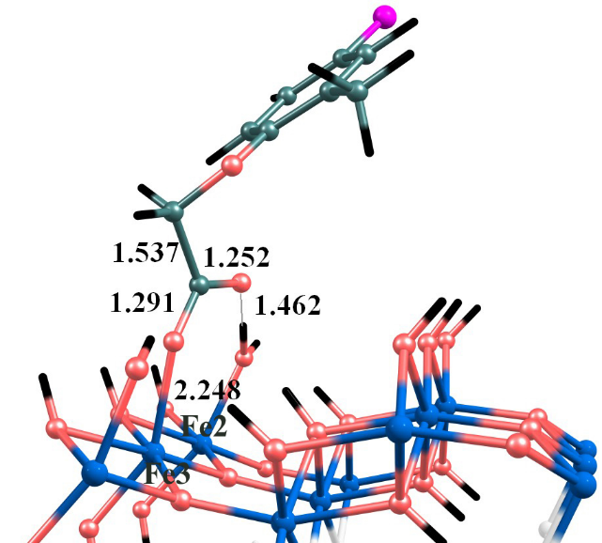

Figure 1: DFT optimized model of MCPA inner sphere complex bound onto the goethite surface.

Reference:
Kersten M., Tunega D., Georgieva I., Vlasova N., Branscheid R. (2014): Adsorption of the herbicide 4-chloro-2-methylphenoxyacetic acid (MCPA) by goethite. Environ. Sci. Technol. 48, 11803-11810.

