Identification and detection of illicit drugs in mixed urban wastewater from city of Novi Sad

Maja Sremački¹, Srdjan Kovačević¹, Jovana Simić², Ivana Mihajlović¹, Jaroslav Slobodnik³, Mirjana Vojinović Miloradov¹
¹ Department of environmental engineering and occupational safety, Faculty of technical sciences, University of Novi Sad, Trg Dositeja Obradovića 6, 21000, Novi Sad, Serbia majasremacki@uns.ac.rs, srdjankovacevic@uns.ac.rs, miloradov@uns.ac.rs, ivanamihajlovic@uns.ac.rs
² Department of civil engineering and geodesy, Faculty of technical sciences, University of Novi Sad, Trg Dositeja Obradovića 6, 21000, Novi Sad, Serbia jovanasimic@uns.ac.rs
³ Environmental Institute, S.r.o., Okružná 784 97241 Koš 972 41, Slovakia slobodnik@ei.sk

Illicit drugs are the latest group of emerging compounds identified in the aquatic environment. These compounds, as already stated for pharmaceuticals [1], reach surface waters unaltered or slightly transformed via wastewater effluents. Mixed wastewater from urban areas is the dominant source of illicit drugs and their metabolites in surface water. The results represent an introduction to a new approach to organic contamination monitoring of waste and surface water. They have been obtained within the Norwegian Institute for Water Research (NIVA) collaboration Project, under the supervision of the Swiss Federal Institute of Aquatic Science and Technology (Eawag).
24h composite samples of mixed urban wastewater were collected over a period of 7 days from selected location in city of Novi Sad, Serbia. Novi Sad is the administrative seat of the province of Vojvodina and has a population of about 400,000 people. The city is situated on Danube, where mixed wastewater, municipal and industrial, is directly discharged without any treatment from four collectors. Samples were analyzed for the presence of cocaine, benzoylecgonine, amphetamines, ecstasy, methamphetamine and cannabis metabolite THC - COOH. Selected compounds were quantified using liquid chromatography tandem mass spectrometry (HPLC - MS²) or high resolution mass spectrometry (HPLC - HRMS). In samples of wastewater at a selected site (main discharge of wastewater – GC2) the presence of all monitored analytes was confirmed in concentration levels of ng/L. [2]
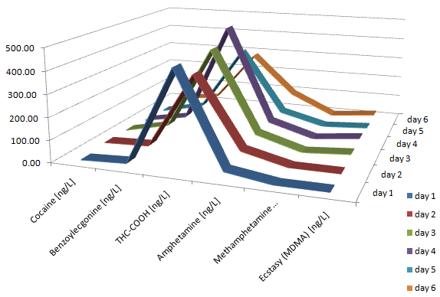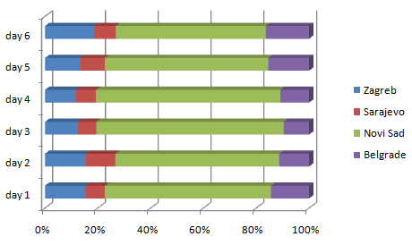
Figure 1. Concentration levels of selected compounds and contribution of Novi Sad in THC-COOH excretions to surface water in Balkan region

- Daughton, C.G. "Illicit Drugs in Municipal Sewage: Proposed New Non-Intrusive Tool to Heighten Public Awareness of Societal Use of Illicit/Abused Drugs and Their Potential for Ecological Consequences," Pharmaceuticals and Personal Care Products in the Environment: Scientific and Regulatory Issues, Symposium Series 791; ACS, Washington, D.C., 2001, pp. 348-364.
- Ort C. et al. Addiction, Societ for the study of Addiction, research raport doi: 10.1111/add.12570

