Particulate emissions of a modern wood stove

Olaf Böge, Zhijun Wu, Yoshiteru iinuma, Alfred Wiedensohler, Hartmut Herrmann
Leibniz-Institut für Troposphärenforschung, Permoserstr. 15, D-04318 Leipzig, Germany

In response to global warming, the use of biomass fuels is increasing as climate neutral fuels are sought. The use of wood for domestic heating has been heavily driven in the EU and also in Germany over the last years.
In 2008 ca.14 Mio small stoves and boilers for solid fuel are used in Germany most of them are operated by wood. During the last years the number of wood stoves and also the consumption of wood for domestic heating in Germany increase. This causes an continuous increase of the emission of fine particulate matter from domestic heating during the last couple of years, reaching an emission of 30.9 kt in 2012 for PM₁₀ and 29.2 kt for PM_{2.5} (Umweltbundesamt, 2014a). In 2012 the german total PAH emission, as sum of BaP, Benzo(b)fluoranthene, Benzo(k)fluoranthene, Indeno(1,2,3,-cd)pyrene, was 191 t (Umweltbundesamt, 2014b). More than 80% of the PAH emission was caused by domestic heating mostly with wood or wood products as fuel (Umweltbundesamt, 2012).
In this study, particulate emissions of a modern wood stove are investigated using beech and spruce wood logs as fuel. The experiments were performed in the Leipzig Biomass Burning Facility (LBBF). Several online instruments including a Scanning Mobility Particle Sizer, an Aerosol Mass Spectrometer, a Multi-Angle Absorption Photometer and analyzers for CO and CO₂ were used to measure the properties of the aerosols. Additionally, the particles were sampled on filters and size segregated with a 10-stage Berner impactor for offline chemical characterization. The filters and impactor foils were used for measuring the particulate mass, organic carbon (OC), elemental carbon (EC), soluble inorganic ions and organic compounds especially PAHs.
The measured particulate emissions from the modern wood stove using spruce as fuel are much lower compared to published emission factors. Particulate emissions from beech combustion are comparable to the published lower emission factors. PAH emissions from beech combustion are clearly higher than from spruce (Fig. 1). Particulate emission data for PM, soluble iorganic ions, OC and EC as well as PAHs will be presented and discussed in detail.

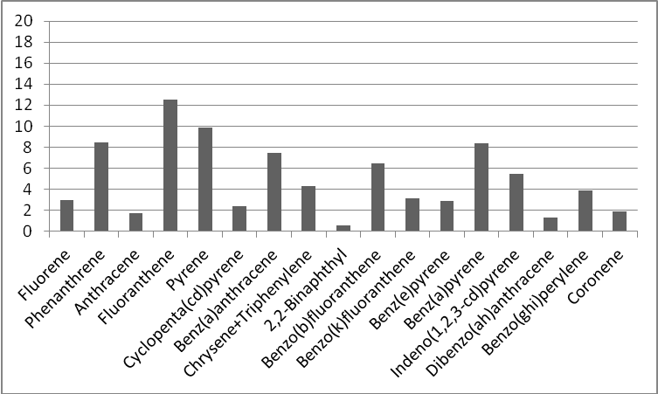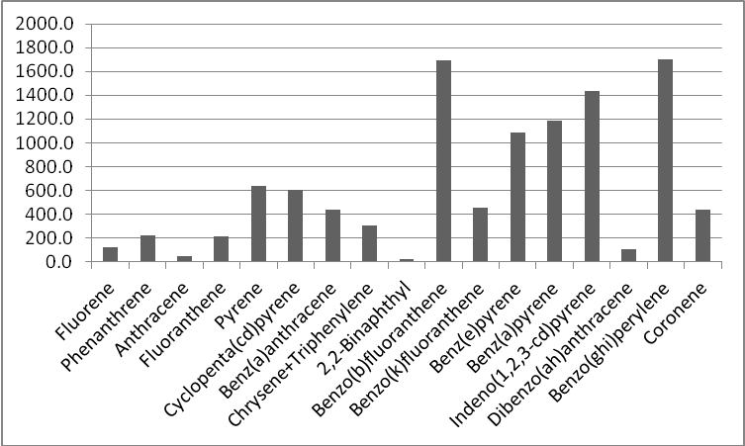
Fig. 1.Particulate emissions of PAHs in PM₁ from spruce (left part) and beech (right part) [μg/kg dry fuel]

These investigations were supported by the German Federal Ministry of Environment.

Umweltbundesamt 2012. Polyzyklische Aromatische Kohlenwasserstoffe: Umweltschädlich! Giftig! Unvermeidbar? http://www.umweltbundesamt.de/sites/default/files/medien/publikation/long/4372.pdf
Umweltbundesamt 2014a. Emission trends for Germany since 1995, PM10 and PM2.5 in kt. Emissionsentwicklung 1990-2012 für klassische Luftschadstoffe. http://www.umweltbundesamt.de/themen/luft/emissionen-von-luftschadstoffen
Umweltbundesamt, 2014b. Emission trends for Germany since 1990, PAH totals in kg. Emissionsentwicklung 1990-2012 für persistente organische Schadstoffe. http://www.umweltbundesamt.de/themen/luft/emissionen-von-luftschadstoffen

