Assessing effects of land-use on water quality in Qinhuai River watershed
Xiaoxue Ma¹, Lachun Wang^{1*}, Lei Ma¹
¹ School of Geographic and Oceanographic Sciences, Nanjing University, Nanjing, China.

Abstract: The land use in China has changed during the past decades, which caused water quality deterioration. Water quality are key water environmental indicators which are sensitive to various land use change. The aim of this study is to evaluate the relationship between land use and water quality at Qinhuai River watershed. Main pollutants (NH₄⁺ -N, TN, TP, BOD₅, COD_{Mn}, DO et al.,) of water quality in Qinhuai River watershed were analyzed. Land use condition of Qinhuai River Watershed in 2005, 2008, 2010 was investigated by GIS thematic map and overlaying analysis. The characteristics of land use/cover change were acquired based on the conversion matrix of land-use change from 2005 to 2010. Water quality monitoring stations were set as geographical centers, and a series of buffers were created across five spatial scales (100 m, 200 m, 400 m, 800 m, and 1600 m) to establish the boundaries of hydrologic units and to detect the scale effect with the help of ArcGIS 9.3 software. And then mean value of each water quality indicator at each monitoring site was used to detect the relationship between land use and water quality using Pearson’s correlation analysis.
Keywork: Land use; water quality; scale effect; urbanization; Qinhuai River watershed

Introduction
Numerous problems related to water quality are mainly caused by Land use change (Zampella and Procopio, 2009; Liu and Chen, 2006). Tu (2011) have argued that the relationships between land use types and water quality parameters are not consistent. For example, Tong and Chen (2002) found that TN (total nitrogen), TP (total phosphorus) were significantly positively related to commercial, residential, and agricultural lands on a regional scale in the watersheds of the Ohio State, USA; While Williams (2005) found that TN and TP had no significant correlations with urban and agricultural lands in the Ipswich River watershed, Massachusetts, USA. Although the relationships between land use and water quality are not constant in different regions, industrial activities and urbanisation exert a high impact on water quality. Yin et al., (2005) argued that the intensity of urban contribution of pollutants much outweighed the agricultural non-point source pollution. Tu and Xia (2008) found that the relationships of land use and water quality are not constant over space, for example, in highly-urbanized area, agricultural land could improve water quality; in less-urbanized area, agricultural activities become important water pollution sources. Wang (2008) indicated that the surface water quality in urban is worse than that in village. Kibena (2014) indicated that settlements and agricultural areas are the ones mainly affecting the water quality in Upper Manyame River. But the relationships between land use and water quality have temporal and spatial differences, caused by the level of urbanization and characteristic of spatio-temporal scales.
Since 2000, growing populations and migration towards have produced a major impact on water environment quality in Qinhuai River watershed. Especially urbanization increases impervious area, alters the configuration, composition and context of land use types. And then urbanization causes local decreases in infiltration, (de Andrade et al., 2008), increase runoff volume ( Olang and Furst, 2010), aggravate water quality (e.g., Ren et al., 2003; Wang et al., 2008; Tu and Xia, 2008 ). Rui (2012) and Han (2007) indicated that present study only relates to impact of land use change on runoff, ignoring the influence of the urbanization on water quality in Qinhuai watershed. Li (2013) indicated that present study ignore spatial and temporal variations of water quality in the whole watershed and the impacts of the urbanization on water quality. So, the relationship between the water quality and land use is needed to study in Qinhuai watershed.

2. Materials and methods

2.1 study area
Qinhuai River watershed is located in the south bank of Nanjing, which has an area of 2631 square kilometers (Fig.1). Qinhuai River watershed encompass Nanjing and Jurong cities of Jiangsu Province, China (Du et al., 2012 ). Its topography like a cattail leaf fan, surrounded by hills and mountains(Liu et al., 2012). Water finally flows into the Yangtze River via the Wuding men water gate and Qinhuai New River in northwest corner of the basin. Watershed lies in the humid climatic region. Average annual rainfall is 1047.8mm. Average temperature is 15.4℃. In recent decades, watershed experienced dramatic urbanization, which has aggravated water quality deterioration.
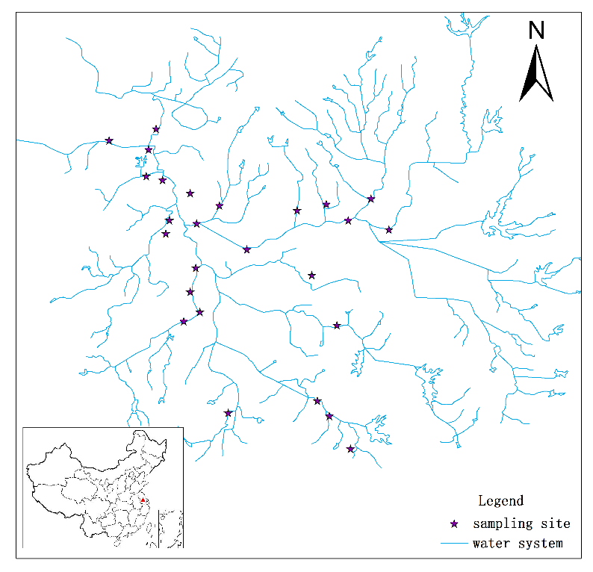
Fig. 1 Study area and spatial distribution of surface water quality monitoring stations

2.2 Land use data
Land use maps were derived from “earth system science data sharing network project”. Land use types for 2005, 2008, 2010 were classified into six categories: (1) Built-up land, (2) Cropland, (3) Forest, (4) Grass, (5) Water body and (6) Unutilized land (Fig. 2). Built-up land refers to areas with impervious manmade surfaces, such as residential and commercial structures and roads. Cropland refers to the land used for producing foodstuffs and vegetables. Forest includes land vegetated with shrubs and trees. Grass primarily consists of green space and grass. Water body consists of stream, reservoir, lake et al. Unutilized land consists of bare land and difficult to use the land. Land use dynamic degree was used to analyze land use change, which indicates an annual variation rate of the area of land use type.

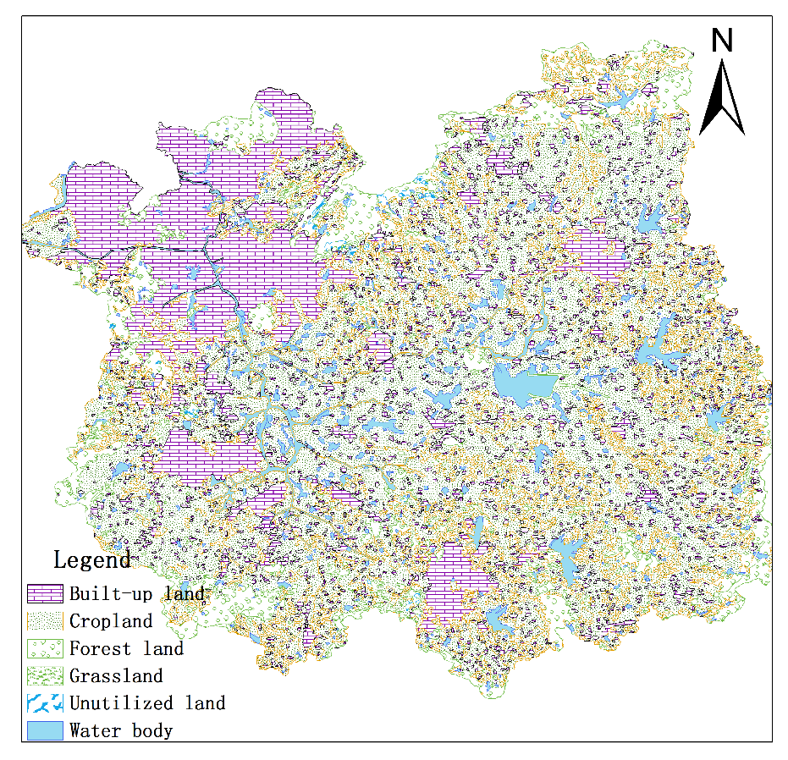
Fig. 2 Land use types in Qinhuai River watershed for 2010

2.3 water quality data
Water quality data were obtained from the Hydrology bureau of Nanjing. These data include 13 water quality parameters measured bimonthly at 27 water quality monitoring sites in 2010. Dissolved oxygen(DO), 5-day biochemical oxygen demand(BOD₅), cadmium-chemical oxygen demand index(COD_{cr}), ammonia nitrogen(NH₄⁺-N), potassium permanganate-chemical oxygen demand index(COD_{mn}), total phosphorus (TP), total nitrogen (TN), pH, temperature, transparency, Electrical conductivity(EC), zinc(Zn), fluoride(F-) were selected as representative organic pollution indicators to assess the water pollution of the Qinhuai River watershed(Zhao et al., 2015). Water quality monitoring stations were set as geographical centers, and a series of buffers were created across five spatial scales (100 m, 200 m, 400 m, 800 m, and 1600 m) to establish the boundaries of hydrologic units and to detect the scale effect with the help of ArcGIS 9.3 software. And then mean value of each water quality indicator at each monitoring site was used to detect the relationship between land use and water quality using Pearson’s correlation analysis.

Reference
[1]Zampella R A, Procopio N A. Landscape Patterns and Water-Quality Relationships in New Jersey Pinelands Streams. Pinelands Commission, New Jersey, USA, 2009.
[2]Liu Y B, Chen Y N. Impact of population growth and land-use change on water resources and ecosystems of the arid Tarim River Basin in Western China. The International Journal of Sustainable Development and World Ecology, 2006, 13(4): 295–305.
[3]Tu J. Spatially varying relationships between land use and water quality across an urbanization gradient explored by geographically weighted regression. Applied Geography, 2011, 31(1):376-392.
[4]Tong S T Y, Chen W. Modeling the relationship between land use and surface water quality. Journal of Environmental Management, 2002, 66(4):377-393.
[5]Williams M, Hopkinson C, Rastetter E, et al. Relationships of land use and stream solute concentrations in the Ipswich River basin, northeastern Massachusetts. Water, Air, and Soil Pollution, 2005, 161(1-4): 55-74.
[6]Yin Z Y, Walcott S, Kaplan B, et al. An analysis of the relationship between spatial patterns of water quality and urban development in Shanghai, China. Computers, Environment and Urban Systems, 2005, 29(2): 197-221.
[7]Tu J, Xia Z G. Examining spatially varying relationships between land use and water quality using geographically weighted regression I: model design and evaluation. Science of the total environment, 2008, 407(1): 358-378.
[8]Wang J, Da L, Song K, et al. Temporal variations of surface water quality in urban, suburban and rural areas during rapid urbanization in Shanghai, China. Environmental Pollution, 2008, 152(2): 387-393.
[9]Kibena J, Nhapi I, Gumindoga W. Assessing the relationship between water quality parameters and changes in landuse patterns in the Upper Manyame River, Zimbabwe. Physics and Chemistry of the Earth, Parts A/B/C, 2014, 67:153-163.
[10]de Andrade E M, Palácio H A Q, Souza I H, et al. Land use effects in groundwater composition of an alluvial aquifer (Trussu River, Brazil) by multivariate techniques. Environmental Research, 2008, 106(2): 170-177.
[11]Olang L O, Frust J. Effects of land cover change on flood peak discharge and runoff volumes: model estimates for the Nyando River Basin, Kenya. Hydrological Process, 2010, 25(1): 80-89.
[12]Ren G Y. Climate Change and Water Resources in China. Beijing: Meteorology Press; 2008 in Chinese with an English abstract
[13]Rui HY. Land use changes and its hydrological response in the Qinhuai River basin. Nanjing: Nanjing University, 2012 (In Chinese).
[14]Han L. Effects of land use changes and hydrological process in basin. Nanjing: Hohai University, 2007 ( In Chinese).
[15]Du J, Qian L, Rui H, et al. Assessing the effects of urbanization on annual runoff and flood events using an integrated hydrological modeling system for Qinhuai River basin, China. Journal of Hydrology, 2012, 464(5):127–139.
[16]Liu Y, Xu YP, Shi Y. Hydrological Effects of Urbanization in the Qinhuai River Basin, China. Procedia Engineering, 2012:767–771.
[17]Zhao J, Lin L, Yang K, et al. Influences of land use on water quality in a reticular river network area: A case study in Shanghai, China. Landscape & Urban Planning, 2015:20–29.

