Potassium-catalyzed diesel soot combustion: from bench studies to mechanical studies

Yexin Zhang¹, Pengfei Yu², Gang Wang², Qian Li³, Jian Zhang¹, Zhaoliang Zhang³
¹ Institute of New Energy Technologies, Ningbo Institute of Materials Technology & Engineering, Chinese Academy of Sciences, 1219 Zhongguan West Road, Ningbo 315201, China, zhangyexin@nimte.ac.cn
² Wuxi Weifu Environmental Catalysts Co., LTD, 9 Lingjiang Road, Wuxi 214028, China.
³ School of Chemistry and Chemical Engineering, University of Jinan, 106 Jiwei Rd., Jinan 250022, China.

The particulate soot emitted from diesel vehicles contributes to the heavy haze which is able to cause a variety of respiratory and cardiovascular diseases harming human health. In order to reduce their emission, diesel particulate filter (DPF), which can trap above 90% soot, has been generally used in diesel vehicles. The trapped soot should be burned out to keep the low pressure of DPF, but the ignition temperature of soot (ca. 600 °C) is beyond the normal diesel exhaust temperatures (175−400 °C). For this, several catalysts for soot combustion have been studied and coated on the channel walls of DPF to develop catalyzed DPF (CDPF). Among the catalysts, potassium (K)-containing catalysts with low-cost have behaved excellent performance comparable to those of noble metals. Unfortunately, the kind of catalysts have not been practically used in CDPF as like the noble metal catalysts. Furthermore, the catalytic mechanism of K-catalyzed soot combustion is still in dispute.
We developed a K-based CDPF, in which a catalyst of Al₂O₃ supported K was coated on a SiC honeycomb wall-flow filter monolith. The CDPF was connected to the exhaust pipe of a light-duty diesel engine (Figure 1(a)), and a serial of bench tests were performed. The capture efficiency of the CDPF was above 90% in the successive cycles. The trapped soot was burned out in 10 min when the inlet temperature increased to ca. 600 °C. The balance point temperature (BPT), where the burned amount of soot equals to its trapped amount in CDPF while the drop pressure keeps a steady level, were determined as 375 °C (the insert of Fig. 1(a)), close to that of the commercialized noble metal-based CDPF ^{[1]}. Therefore, the K-based CDPF is potential to be used for the reduction of diesel soot emission.
In order to comprehend the catalytic role of K, we investigated the mechanism of K-catalyzed soot combustion. A ketene group was determined as the reaction intermediate by in situ IR characterizations and density functional theory calculations ^{[2-5]}. Thereby, an oxygen spillover mechanism was been proposed. The surface-activated oxygen on K⁺ sites spill over to the surface carbon of soot forming the ketene group, which combine with other active oxygen species to give out CO₂. Further studies with ultraviolet photoelectron spectroscopy and semi-empirical quantum chemical calculations revealed that the nature of the oxygen spillover mechanism is an electron transfer mechanism ^{[6]}. The K⁺ ions attract the electrons from the inner to surface of soot (Fig. 1(b)), improving the reactivity of the surface carbon to the electrophilic species such as oxygen molecules.
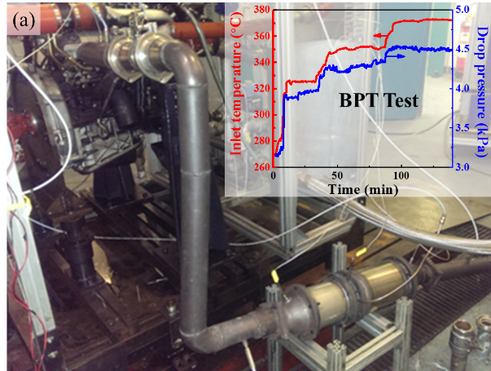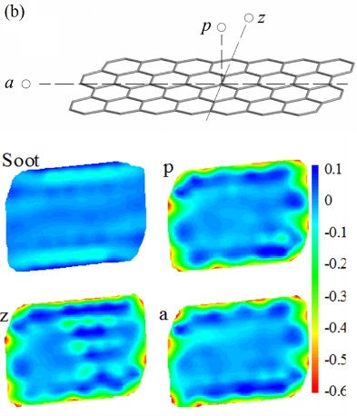
Fig. 1 (a) Digital photo of equipment for the bench tests on a light-duty diesel engine, the insert shows the inlet temperature and drop pressure of CDPF during the BPT test; (b) Contour plots of net charges calculated by semi-empirical methods for soot (the model of polycyclic aromatic hydrocarbon) and the cases in the presence of the K⁺ ion at the locations of p, z and a.

References
[1] Tang T, Zhang J, Cao D, Shuai S, Zhao Y, J. Environ. Sci. 2014, 26(12): 2434−2439.
[2] Zhang Z, Zhang Y, Wang Z, Gao X. J. Catal. 2010, 271 (1): 12−21.
[3] Zhang Z, Zhang Y, Su Q, Wang Z, Li Q, Gao X. Environ. Sci. Technol. 2010, 44 (21): 8254−8258.
[4] Zhang Y, Su Q, Li Q, Wang Z, Gao X. Chem. Eng. Technol. 2011, 34 (11): 1864−1868.
[5] Zhang Y, Chen S, Li Q, Zhang Z, Zhang J. Chin. Sci. Bull. 2014, 59(31): 4003−4007.
[6] Li Q, Wang X, Xin Y, Zhang Z, Zhang Y, Hao C, Meng M, Zheng L, Zheng L. Sci. Rep. 2014, 4: 4725.

